All Data

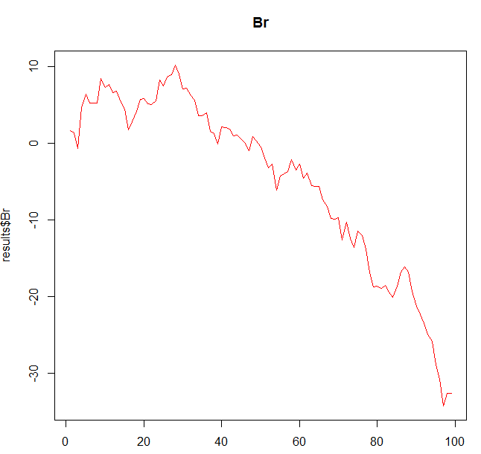

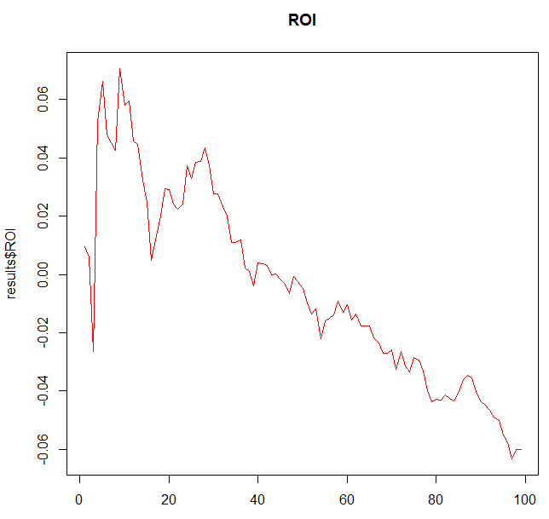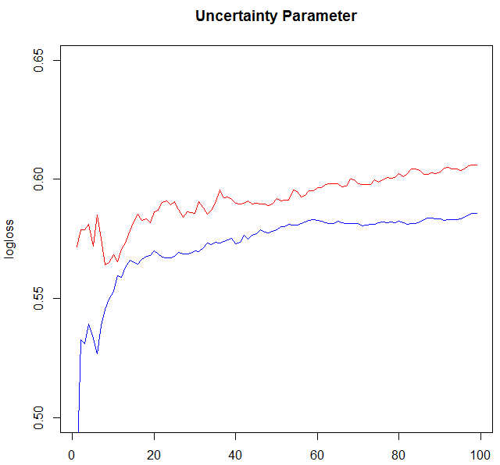

3 Different models:

Hard

Coefficients:

Estimate Std. Error z value Pr(>|z|)

ratingdiff 0.0028102 0.0005887 4.774 1.81e-06 \*\*\*

ratingdiffCurrentSurface 0.0020457 0.0005611 3.646 0.000267 \*\*\*

DummyBo5TimesAvgRatingdiff 0.0023269 0.0006790 3.427 0.000611 \*\*\*

RetiredOrWalkoverDiff 0.2528915 0.2127155 1.189 0.234490

FatigueDiff -0.0129739 0.0049947 -2.598 0.009389 \*\*

HeadtoHead 0.0043589 0.0165982 0.263 0.792848

Clay

Coefficients:

Estimate Std. Error z value Pr(>|z|)

ratingdiff 0.0018536 0.0004335 4.275 1.91e-05 \*\*\*

ratingdiffCurrentSurface 0.0036695 0.0004149 8.844 < 2e-16 \*\*\*

DummyBo5TimesAvgRatingdiff 0.0017668 0.0008761 2.017 0.0437 \*

RetiredOrWalkoverDiff -0.4075360 0.2757135 -1.478 0.1394

FatigueDiff -0.0085570 0.0069381 -1.233 0.2175

HeadtoHead 0.0102277 0.0255275 0.401 0.6887

Quantile = 0.3:

Grass

Coefficients:

Estimate Std. Error z value Pr(>|z|)

ratingdiff 0.0027332 0.0006280 4.353 1.35e-05 \*\*\*

ratingdiffCurrentSurface 0.0017578 0.0005797 3.032 0.00243 \*\*

DummyBo5TimesAvgRatingdiff 0.0031717 0.0010907 2.908 0.00364 \*\*

RetiredOrWalkoverDiff -0.2336628 0.4191542 -0.557 0.57721

FatigueDiff 0.0005582 0.0120730 0.046 0.96312

HeadtoHead 0.0109541 0.0434354 0.252 0.80089

As will we be seen later, Clay is very unreliable looking at these regressions it seems to me that this is because ratingdiff is very small compared to ratingdiffcurrentsurface. So the problem which arises now is that Clay depends most on its surfaces rating, but this variable is less reliable than the variable ratingdiff due to the games in it.

Therefore I decided to remove all Clay games later so we predict only the most reliable matches.

Also noticeable is that Fatigue diff is not important at all for Grass, probably because this surface causes less rallies.

Hard:

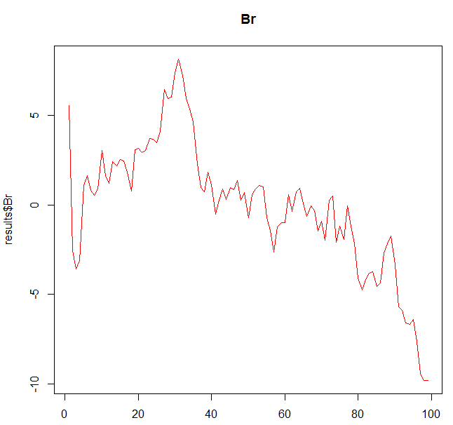

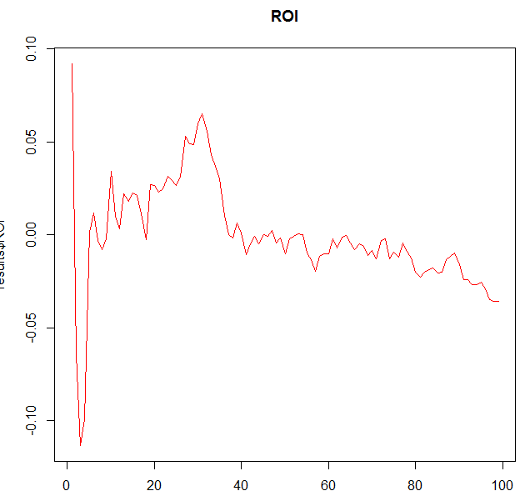

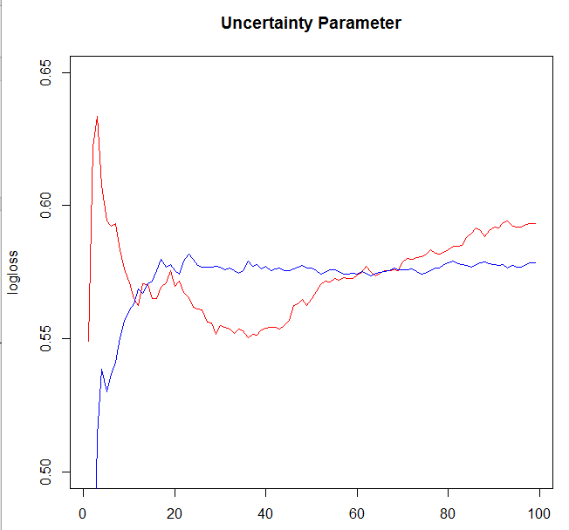

Clay

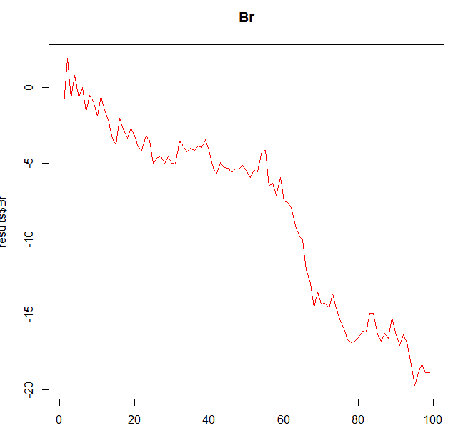

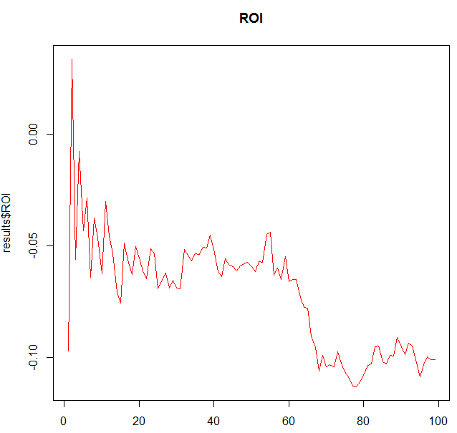

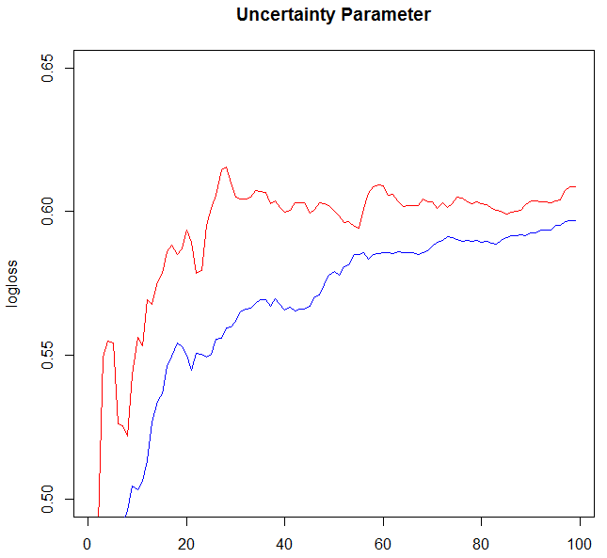

Grass

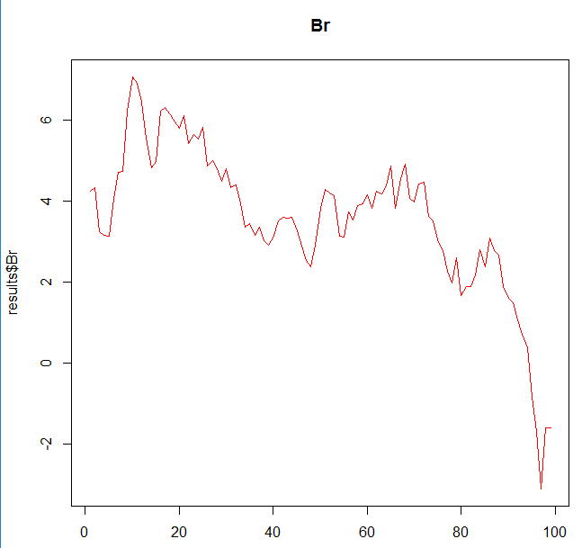

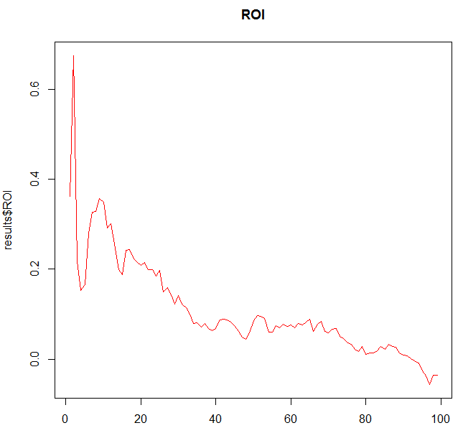

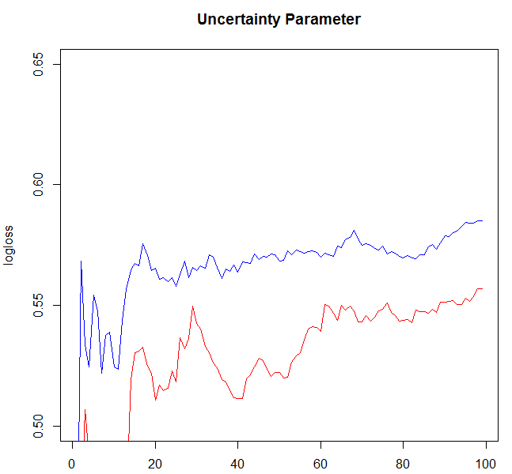

So maybe merge only Grass and Hard, they seem to both be pretty predictable

